Nama : Abdi Akhsanul Afkar

NIM : 18090048

Kelas : 5C

PRAKTEK W2

1. Code

latihan1-application/controller

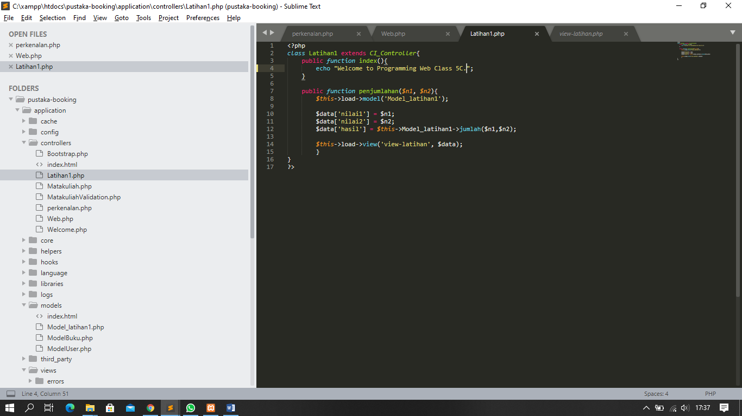

Model_latihan1 - application/models

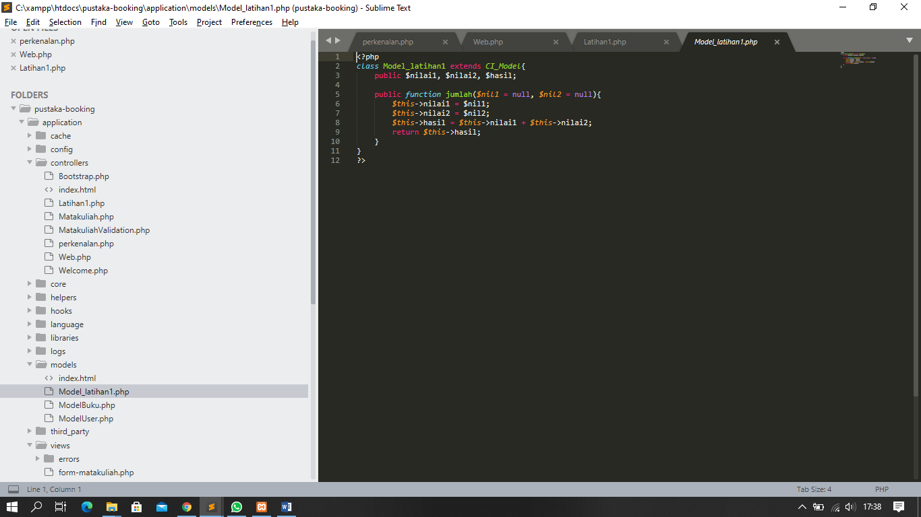

View_latihan - application/view

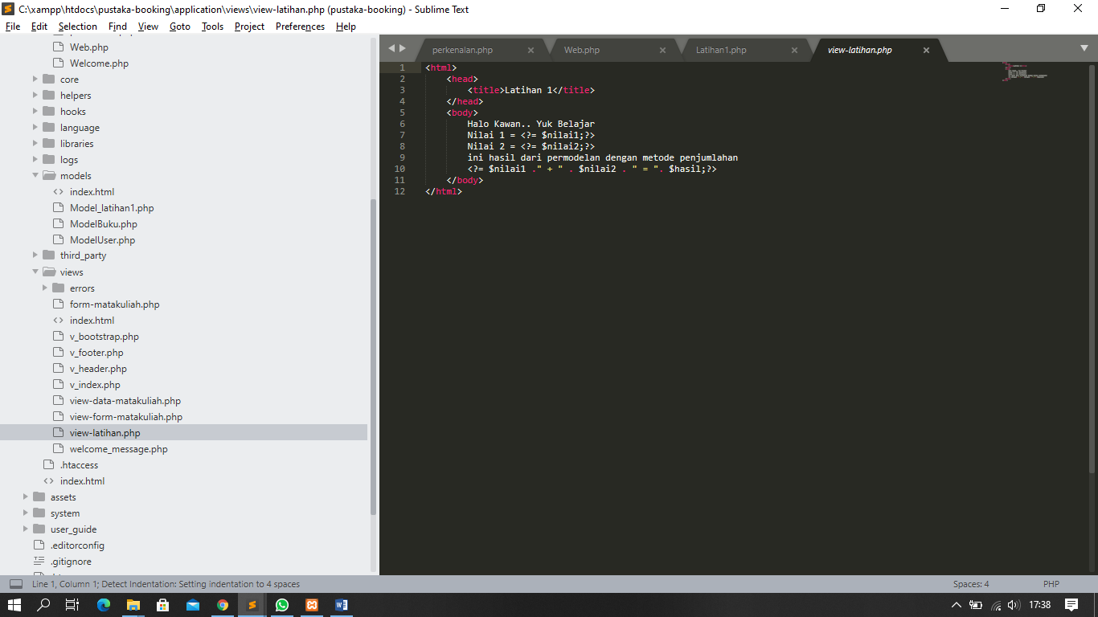

1. URL

[http://localhost/pustaka](http://localhost/pustaka_haniff/index.php/latihan2)-booking/latihan1

[http://localhost/pustaka](http://localhost/pustaka_haniff/index.php/latihan2)-booking/latihan1/penjumlahan/6/9

1. Screenshot Hasil

latihan1

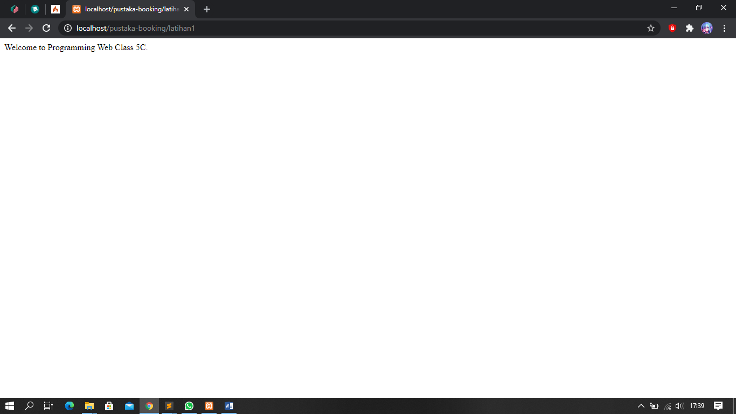

penjumlahan

